1 Walkthrough 33 Routing Back and History

<https://sapui5.hana.ondemand.com/#/topic/8ef57cfd37b44f089f7e3b52d56597eb>



2 Core Changed Codes Compared to Last Version:

2.1 Detail.view.xml 显示返回按钮

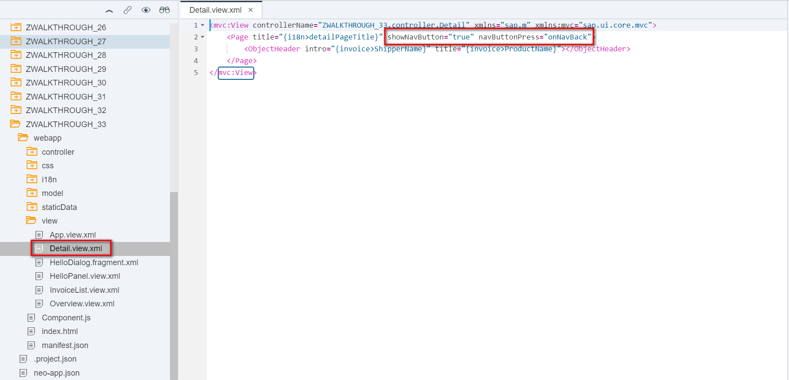

2.2 Detail.controller.js 处理返回按钮行为

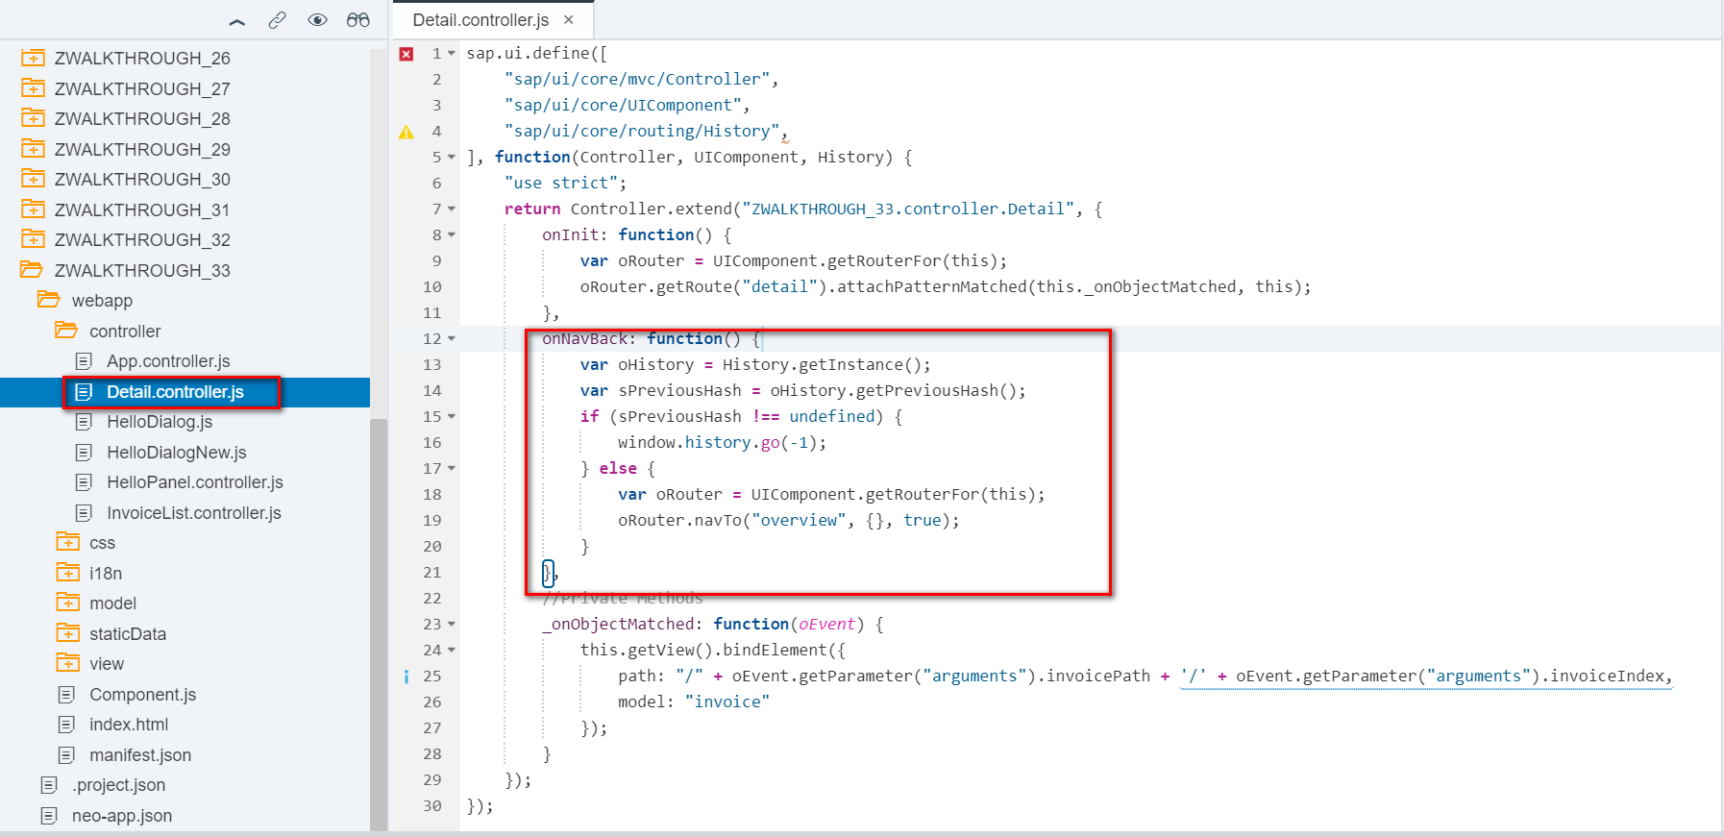

3 i18n 文本对象管理

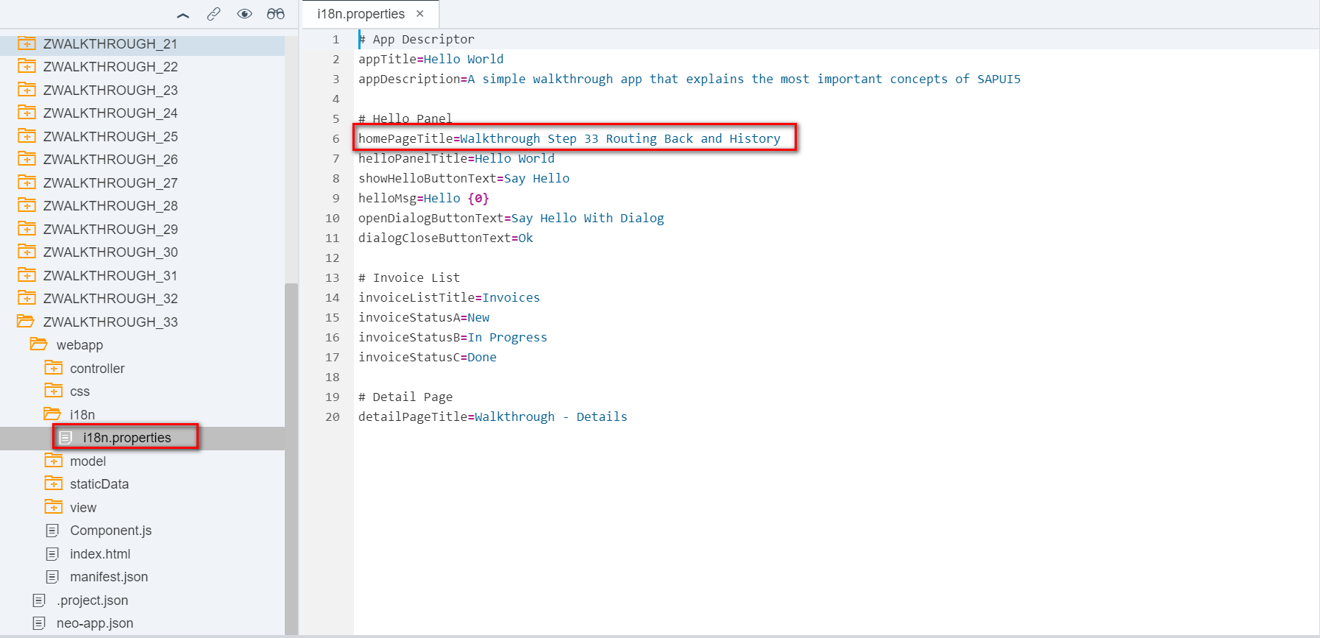

4 Result

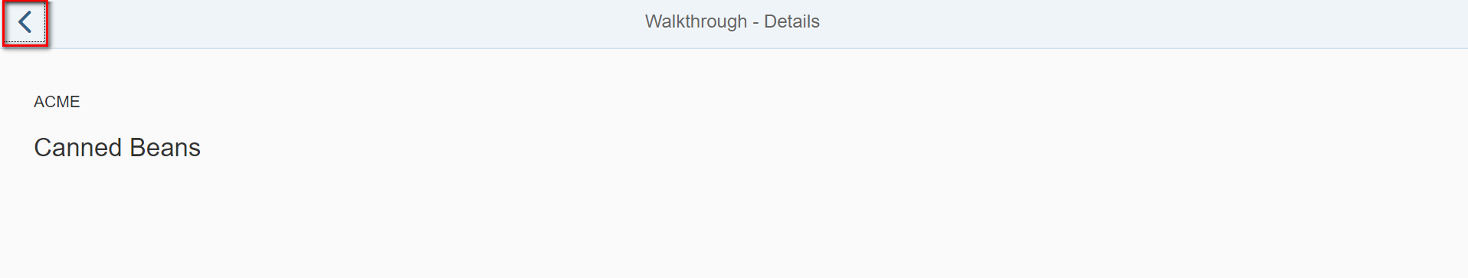

5 Git:

https://github.com/xiexiaop/SAPUI5-2-Round/tree/master/Projects/ZWALKTHROUGH_33

2019/02/08 XiaoMi Beijing Zac,Xie